

Laboratorio #5

**Docente: prof. Oriel Cedeño**

**Asignatura: Programación VI**

**Alumno:** Mark Trejos – 8-999-582

**Carrera:** Lic. Ingeniería en Sistemas

**Cuatrimestre: 7mo**

**Año: 2024**

Código:

Archivos:

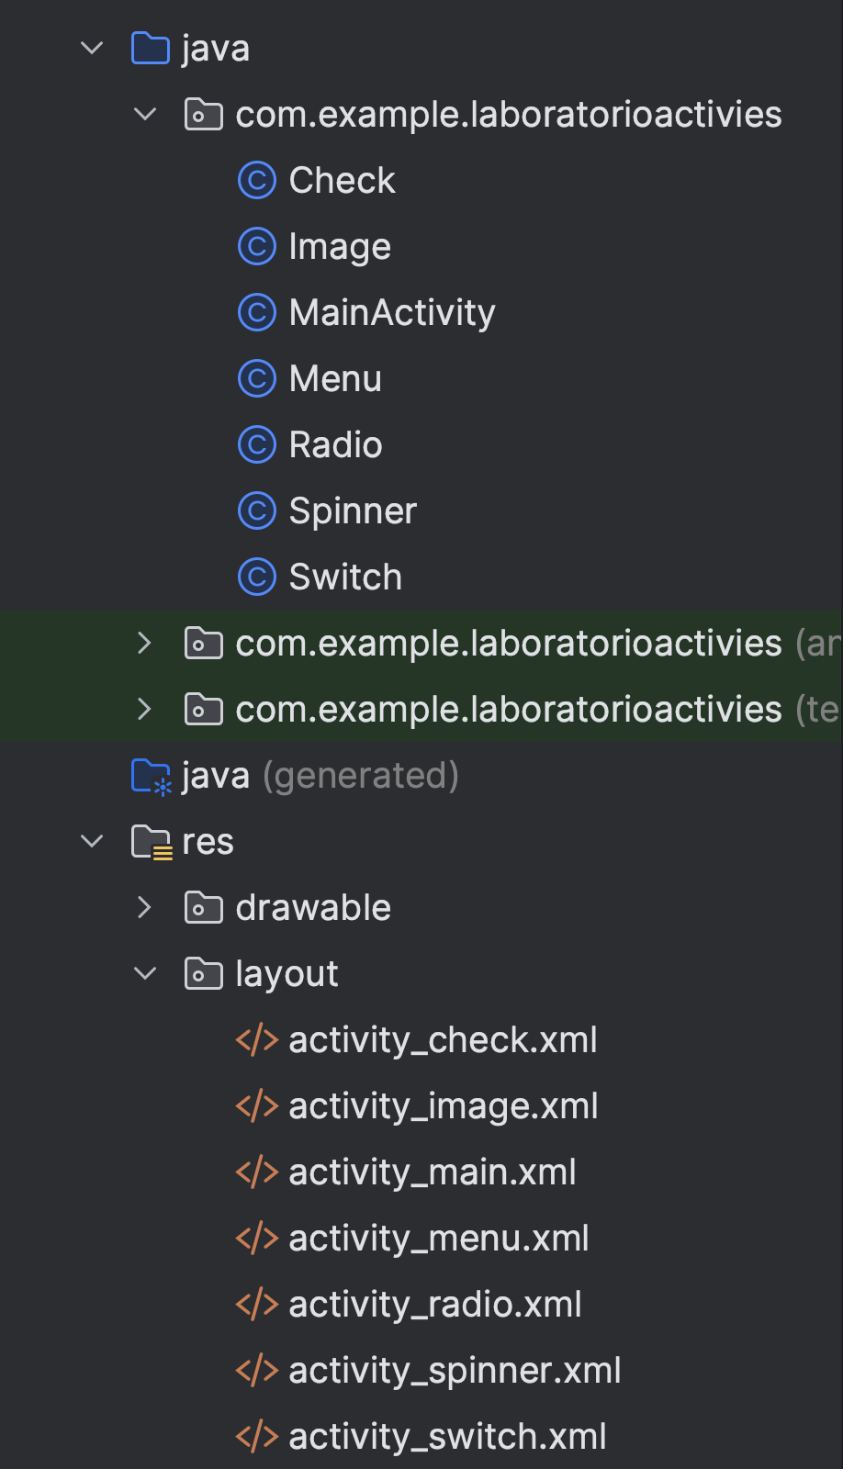

# Main Activity:

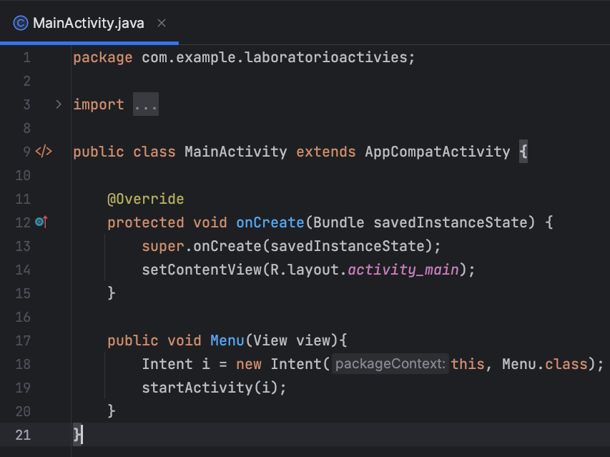

Este código muestra un botón que dice operar y abre el menú de opciones.

# Menu:

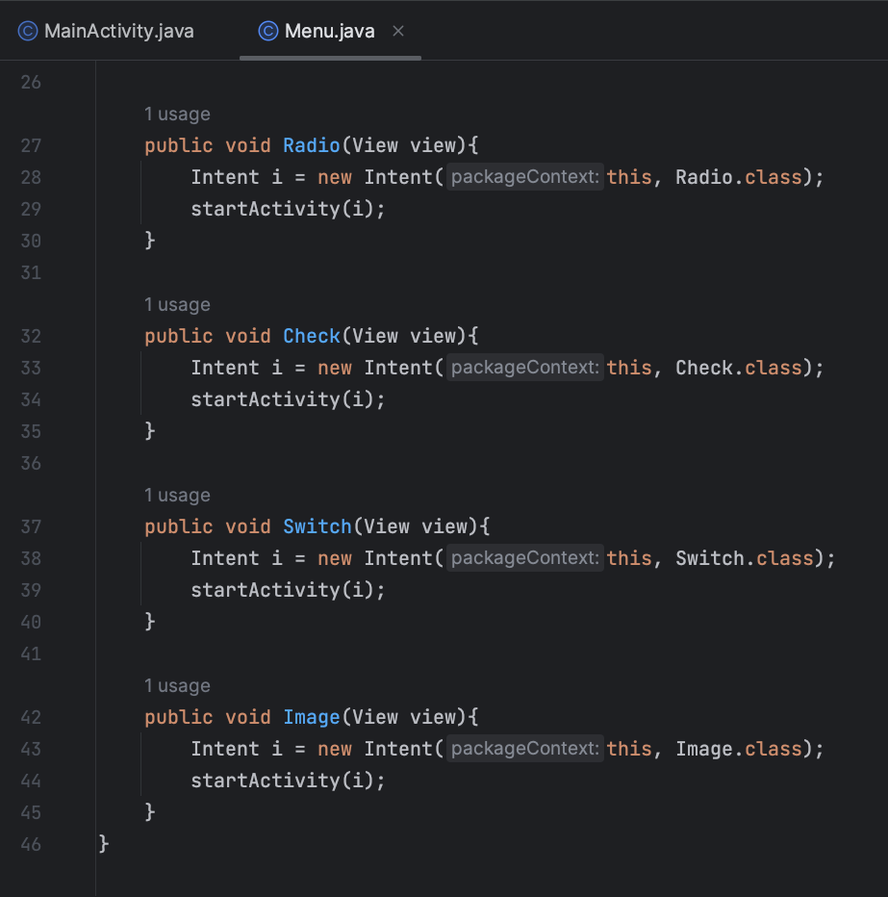

Esta clase contiene una serie de botones, cada uno de estos botones activan sus métodos correspondientes que redirigen hacia sus respectivas actividades.

# Check



